NURUL HUDA FAIZAH 22012889

a) Title: Little Abqari Pre-School

b) Goals:

1. Create a simple and neat responsive website to improve onsite user experience.

2. Link media social on the website.

3. User data based (get data from user) by using php

c) OUTPUT SCREENSHOTS: WEBSITE

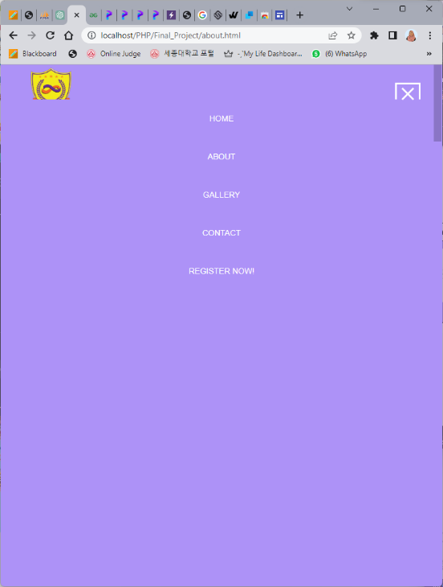HOME ABOUT NAVIGATION BAR

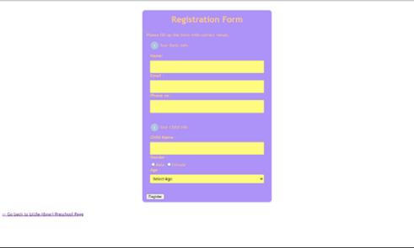GALLERY REGISTRATION CONTACT US

OUTPUT SCREENSHOTS: RESPONSIVE

d) Summary

My code represents a preschool website. This website starts with a navbar area in the header section for all pages that contains the site logo and a menu links to different pages, including a Home, About, Gallery, Contact and Registration page. I also create a footer that includes a newsletter subscription form and social media links for Facebook, Twitter, and Instagram and displays copyright information. Other than that, I made a responsive navigation bar that features a toggle functionality for the mobile version.

In the Homepage, there is three sections in body for the introduction, video section and gallery section. The introduction section features a welcome message and preschool description with a “Read More” button links to the About page. It also displays video that set to autoplay and muted control with poster. The gallery section is a collection of images that can open a full-size image by clicking on image. It also can have navigation buttons to view the previous and next images on the full-size image.

The About page provides details description about the preschool. It also has collection of annual event images by using the same coding and functionality with the gallery section in the homepage.

The Gallery page consists of an image that showcase six slides, each displaying an image with a corresponding number. It also includes a caption container for the title and thumbnail image under the slide that can be clicked to view specific image.

The Contact page offers a contact form where users can submit their inquiries or messages. The form requires input for name, email, phone number, and optional message. Upon submission, the form data is sent to the contact database in the userlap db.

The Registration page provides registration form for parents to provide their basic information and register their child. Upon submission, the form data is sent to the registration database in the userlap db. There is also paragraph with a hyperlink that allows the user to go back to the Little Abqari Preschool homepage.

Overall, the project provided showcases the structure and functionality of a preschool project website, allowing users to navigate through different pages and view an image gallery with interactive features.

e) Source:

<https://www.codepel.com/vanilla-javascript/javascript-navigation-bar/>

<https://www.w3schools.com/howto/tryit.asp?filename=tryhow_css_social_media_buttons2>

<https://htmlcodex.com/kindergarten-website-template/>

<https://html.design/demo/fanadesh/index.html>

<https://www.educative.io/answers/how-to-create-a-registration-form-with-html>

<https://www.w3schools.com/howto/howto_js_slideshow_gallery.asp>

f) Major Code Description:

My code consists of four HTML code which is for the homepage, About, Gallery and Contact page. The header and footer sections are consistent across all pages, containing navigation links to Home, About, Gallery, Contact and Registration page.

I also created responsive menu toggle button that used JavaScript code functionality. The toggle button triggers the togglerClick() function, which toggles the visibility of the gallery section. Clicking a navigation link triggers the navLinkClick() function, which closes the menu if it's open and displays the gallery section (‘showGallery()’).

As for the footer, there is a ‘footer_section’ in the in the body section that consists of a subscription newsletter to submit an email, social media links to Facebook, Instagram, and Twitter and a copyright information in the footer.

There were a ‘top_container’ section in homepage, ‘top_about’ section in About and ‘top_gallery’ section in Gallery for the header that style to insert the background picture on the website.

In the homepage and About page, there was a ‘gallery_section’ that have a collection of images and it will rotate as you hover on it. I used a JavaScript to open the full-size image with navigation previous and next button to view the previous or next image and the exit button to exit the full-size image as you click on the “X”.

I use php database for the registration and contact page. There is a ‘config.php’ to connect the page with database mySQL. The registration page (‘registration.php’) uses PHP and a form to collect parents' and child's information. The form data is processed using the POST method and sent to the ‘register.php’ file for database storage.

As for the contact page, the information was taken in ‘contact.html’ but the form takes an action attribute that points to ‘contact.php’ for processing the form data.

The gallery section is hidden by default, but it can be toggled to appear or disappear by clicking the gallery nav-link or using the toggle button. When the gallery nav-link is pressed, the ‘navLinkClick()’ function is triggered, which checks if the navigation menu is open and closes it by simulating a click on the toggle button. It then calls the ‘showGallery()’ function to display the gallery section.

g) Conclusion

In conclusion, I created a responsive preschool website with multiple pages and interactive features. It includes a consistent header and footer design throughout the website. The header includes navigation menu and toggle button for mobile devices. The footer includes a newsletter subscription form and links to the preschool's social media accounts. It also provides a user-friendly form for contact and registration. Users can explore different pages, view image galleries, and interact with the website's features.

Overall, the website aims to promote the Little Abqari Preschool and facilitate communication with potential parents and interested individuals. It also provides relevant information about the preschool, showcases its activities, and offers a convenient way to contact the institution. The project successfully achieves its goal of creating a simple and neat website with a focus on enhancing user experience.